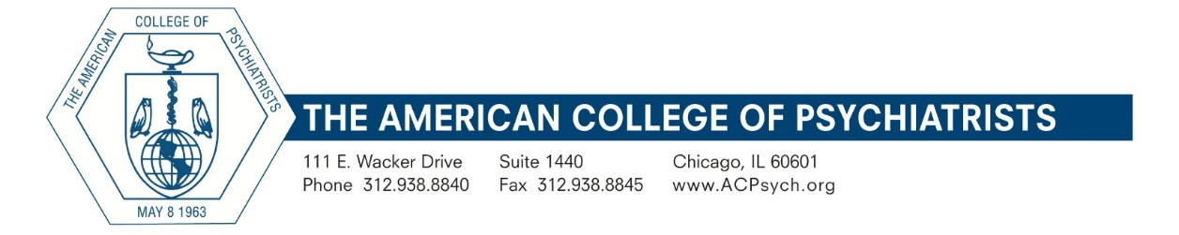

2023 Award for Creativity in Psychiatric Education
Application Form

Please complete and return this application with any supporting materials (not to exceed 30 pages total) by email to nathan@acpsych.org by June 30, 2022
Guidelines
This Award is open to any creative/innovative program for psychiatric education that has been in operation for at least two years, includes program outcome data, and has been a part of a U.S. or Canadian psychiatric residency training program approved by ACGME or The Royal College. Trainees may include medical students, residents, other physicians, allied mental health professionals, or members of the community. The program and any contributors must be free from commercial interest or benefit. Applicants must submit a completed form and related documentation by June 30, with the total submission not to exceed 30 pages. Please include all relevant information about your program within these 30 pages; do not rely on hyperlinks as your program's primary source of information.

Applicant Information:
Name of person completing this application:

Title:
Name of educational program: (e.g., Diversity Training Program):

Institution:
Address:
City: State/Prov:
Zip/Postal Code: Country:
E-mail Address: Phone:
Training Director:
Department Chair:

Program Information (use additional space as needed):

1. Brief description of program:

2. In what way is your program creative and innovative?

3. What significant educational issue is addressed by your program?

4. What year did your program begin?

5. Have other academic centers created similar programs modeled on yours? If yes, please specify:

6. Has your program been presented at a national meeting, won awards from other organizations, or been accepted for publication?

7. What method of self-evaluation is integrated into the program? Explain and provide a sample of the evaluation tool as well as any outcome data that the program has generated:

8. Please attach to this application any additional narrative description or other information that would assist the Committee in evaluating your program.

